Aim : Simulate smoothing and sharpening operations on images using frequency domain filters.

Introduction :
Digital image processing is the process of performing various operations on digital images using computer algorithms. Image filtering is one of the important techniques used in digital image processing. Filtering can be used to remove noise, smooth an image, enhance edges, and improve the visual quality of an image.
Image filtering can be performed in two major domains:
- Spatial Domain
- Frequency Domain
In the spatial domain, operations are directly performed on the pixels of an image. In the frequency domain, the image is first transformed into its frequency representation. Filtering is then performed on the frequency components, and the result is transformed back into the spatial domain.
Frequency Domain :
An image contains different frequency components. Low-frequency components represent slowly changing regions such as smooth backgrounds and gradual intensity changes. High-frequency components represent rapid changes in intensity, such as edges, boundaries, fine details, and noise.
The Discrete Fourier Transform (DFT) is commonly used to convert an image from the spatial domain into the frequency domain.
The basic process is:
Input Image → DFT → Frequency-Domain Filtering → Inverse DFT → Output Image

Discreate Fourier Transform :
The two-dimensional DFT of an image can be represented as:
F(u,v) = Σ Σ f(x,y)e^(-j2π(ux/M + vy/N))
where:
- f(x,y) is the input image.
- F(u,v) is the frequency-domain representation.
- x and y represent spatial coordinates.
- u and v represent frequency coordinates.
- M and N represent image dimensions.
The frequency-domain representation allows us to selectively remove or emphasize particular frequency components.

SMOOTHING USING GAUSSIAN LOW-PASS FILTER
Smoothing is used to reduce noise and unwanted fine details from an image. In the frequency domain, smoothing is generally performed using a low-pass filter.
A low-pass filter allows low-frequency components to pass through while reducing high-frequency components.

GAUSSIAN FILTER :
In this experiment, a Gaussian low-pass filter is implemented in the frequency domain.
The Gaussian filter is represented by:
H(u,v) = exp[-D²(u,v) / 2σ²]
where:
- H(u,v) is the Gaussian filter response.
- D(u,v) is the distance from the center of the frequency domain.
- σ is the standard deviation of the Gaussian filter.
The value of σ controls the amount of smoothing.
A smaller value of σ allows fewer frequency components to pass and produces stronger smoothing. A larger value allows more frequencies to pass and produces comparatively less smoothing.

EFFECT OF SMOOTHING
Gaussian smoothing produces the following effects:
- Reduces high-frequency noise.
- Removes small unwanted details.
- Produces a softer image.
- Reduces sharp transitions.
- Can reduce edge clarity.
- Excessive smoothing can cause image blurring.

APPLICATIONS
Smoothing is commonly used in:
- Noise reduction
- Image preprocessing
- Medical image processing
- Object detection
- Computer vision
- Image segmentation
In this experiment, the value:
σ = 20
is used for Gaussian smoothing.

SHARPENING USING HIGH-PASS FILTER :
Sharpening is an image enhancement technique used to emphasize edges and fine details. Unlike smoothing, sharpening emphasizes high-frequency components of an image.
A high-pass filter suppresses low-frequency components and allows high-frequency components to pass through.
High-frequency components generally contain:
- Edges
- Boundaries
- Fine textures
- Rapid intensity changes
- Small image details

HIGH-PASS FILTER
In this experiment, a high-pass filter is created by setting the central low-frequency region of the frequency-domain mask to zero.
The remaining high-frequency components are retained.
The filter mask can be represented conceptually as:
Low Frequencies → Removed
High Frequencies → Passed
The parameter used in the experiment is:
Strength = 20

EFFECT OF SHARPENING :
High-pass filtering produces the following effects:
- Enhances edges.
- Makes fine details more visible.
- Increases apparent image sharpness.
- Highlights boundaries.
- Enhances rapid intensity changes.
- May also increase noise.
If the sharpening strength is too high, the output may contain excessive edge enhancement and may appear unnatural.

APPLICATIONS :
Sharpening is commonly used in:
- Image enhancement
- Document processing
- Medical image analysis
- Photography
- Object recognition
- Edge detection
- Computer vision

SOFTWARE REQUIREMENTS Used:
- Python 3
- Antigravity
- OpenCV
- NumPy
- Matplotlib

Code :
import cv2
import numpy as np
import matplotlib.pyplot as plt

def gaussian_filter(image, sigma):
image = np.float32(image)
dft = cv2.dft(image, flags=cv2.DFT_COMPLEX_OUTPUT)
dft_shift = np.fft.fftshift(dft)
h, w = image.shape
cy = h // 2
cx = w // 2
y, x = np.ogrid[:h, :w]
distance = (x - cx) ** 2 + (y - cy) ** 2
gaussian = np.exp(-distance / (2 * sigma * sigma))
mask = np.zeros((h, w, 2), np.float32)
mask[:, :, 0] = gaussian
mask[:, :, 1] = gaussian
result = dft_shift * mask
result = np.fft.ifftshift(result)
output = cv2.idft(result, flags=cv2.DFT_SCALE | cv2.DFT_REAL_OUTPUT)
output = cv2.normalize(output, None, 0, 255, cv2.NORM_MINMAX)
return np.uint8(output)

def high_pass_filter(image, strength):
image = np.float32(image)
dft = cv2.dft(image, flags=cv2.DFT_COMPLEX_OUTPUT)
dft_shift = np.fft.fftshift(dft)
h, w = image.shape
cy = h // 2
cx = w // 2
mask = np.ones((h, w, 2), np.float32)
mask[cy - strength:cy + strength, cx - strength:cx + strength] = 0
result = dft_shift * mask
result = np.fft.ifftshift(result)
output = cv2.idft(result, flags=cv2.DFT_SCALE | cv2.DFT_REAL_OUTPUT)
output = cv2.normalize(output, None, 0, 255, cv2.NORM_MINMAX)
return np.uint8(output)

image_paths = [
"smoothening data1.png",
"smoothening data2.png",
"smoothening data3.png",
"smoothening data4.png",
"smoothening data5.png"
]
sigma = 20
strength = 20
for i in range(5):
image = cv2.imread(image_paths[i], cv2.IMREAD_GRAYSCALE)
if image is None:
continue
smooth = gaussian_filter(image, sigma)
sharp = high_pass_filter(image, strength)
plt.figure(figsize=(15, 5))
plt.subplot(1, 3, 1)
plt.imshow(image, cmap="gray")
plt.title("Original")
plt.axis("off")
plt.subplot(1, 3, 2)
plt.imshow(smooth, cmap="gray")
plt.title("Gaussian Smoothing")
plt.axis("off")
plt.subplot(1, 3, 3)
plt.imshow(sharp, cmap="gray")
plt.title("High-Pass Sharpening")
plt.axis("off")
plt.suptitle("Experiment 9 - Image " + str(i + 1))
plt.tight_layout()
plt.show()
Outputs :
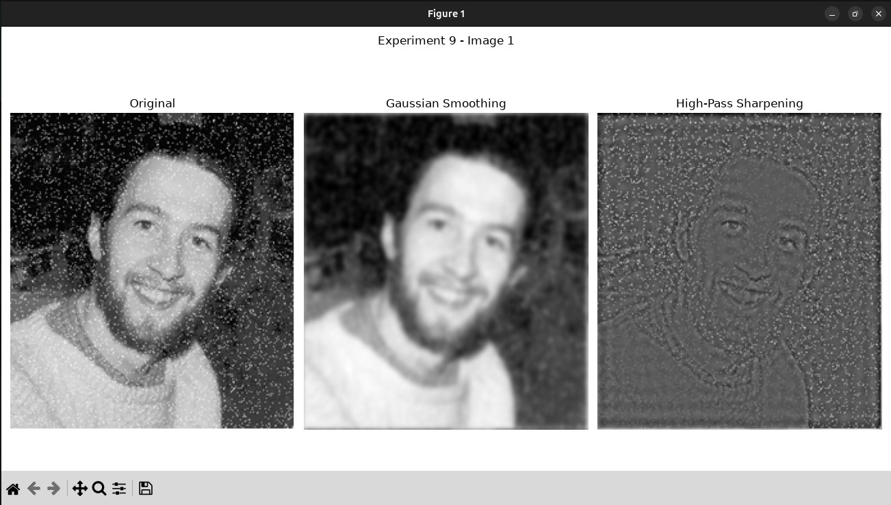
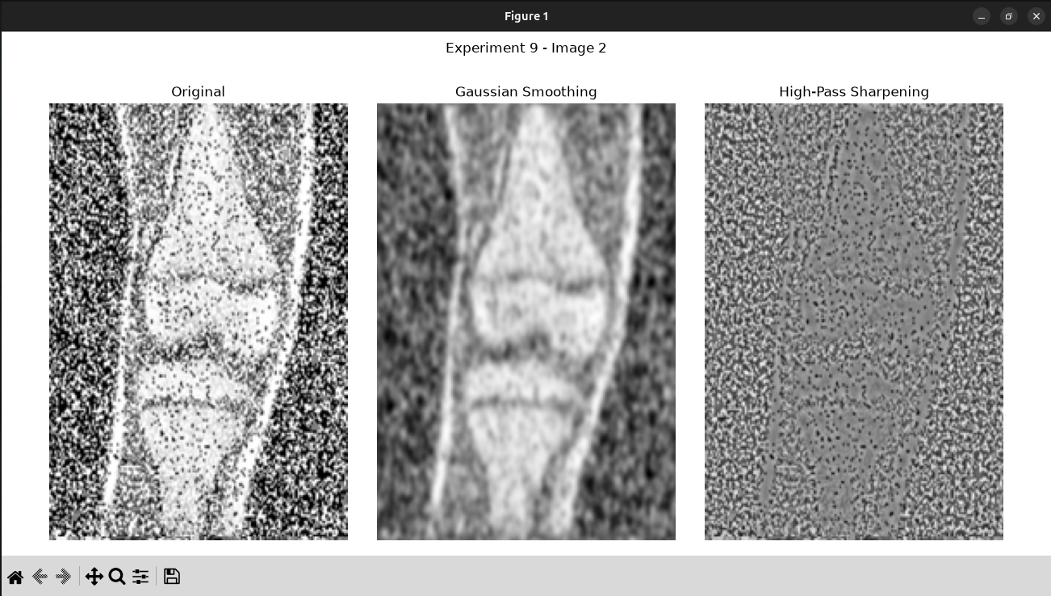
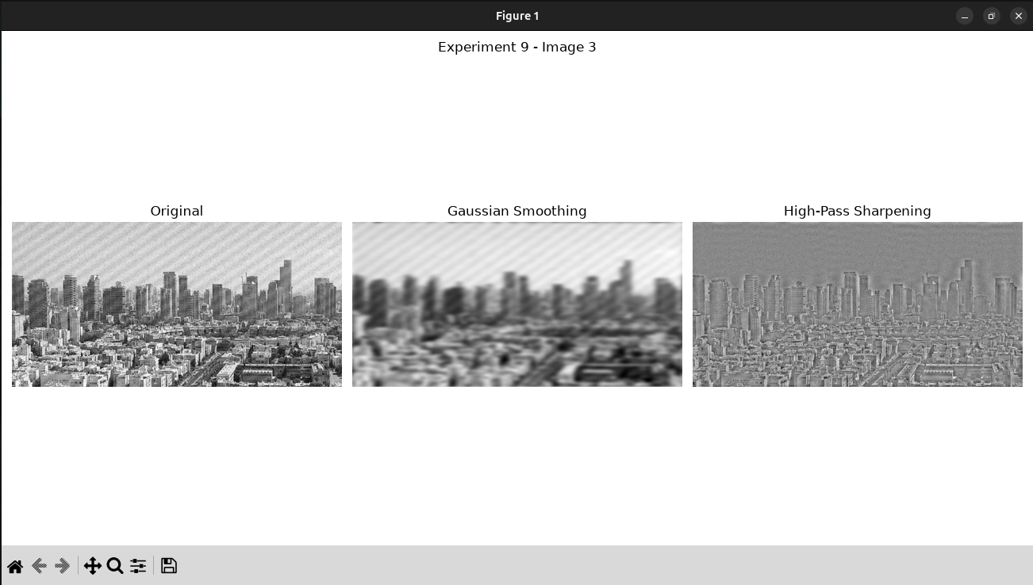
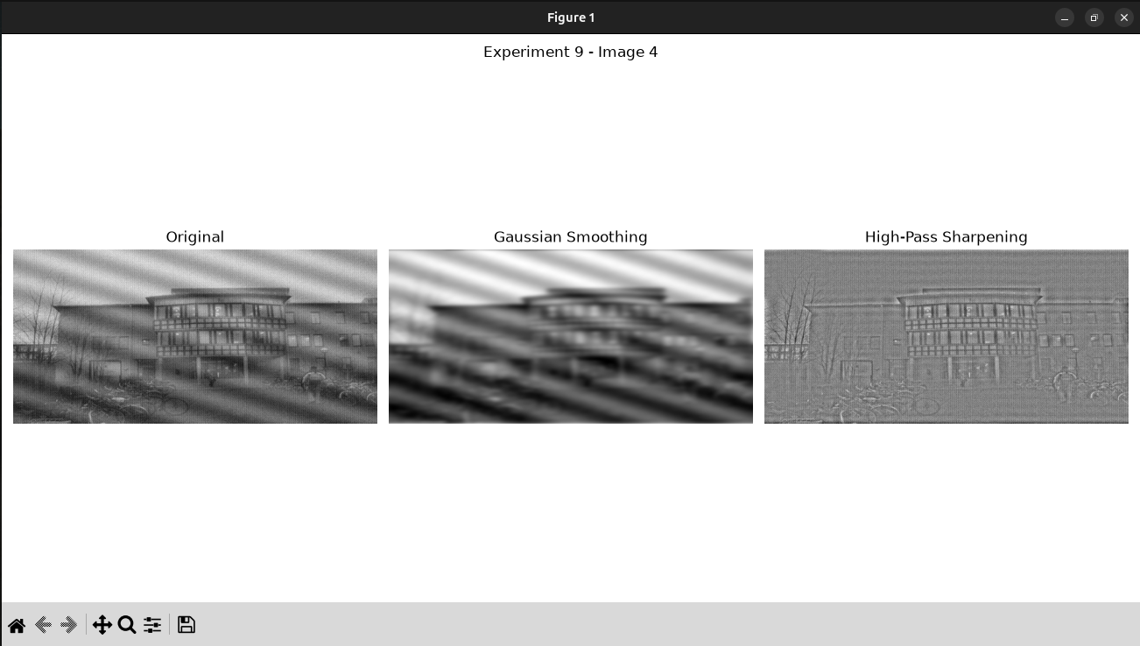

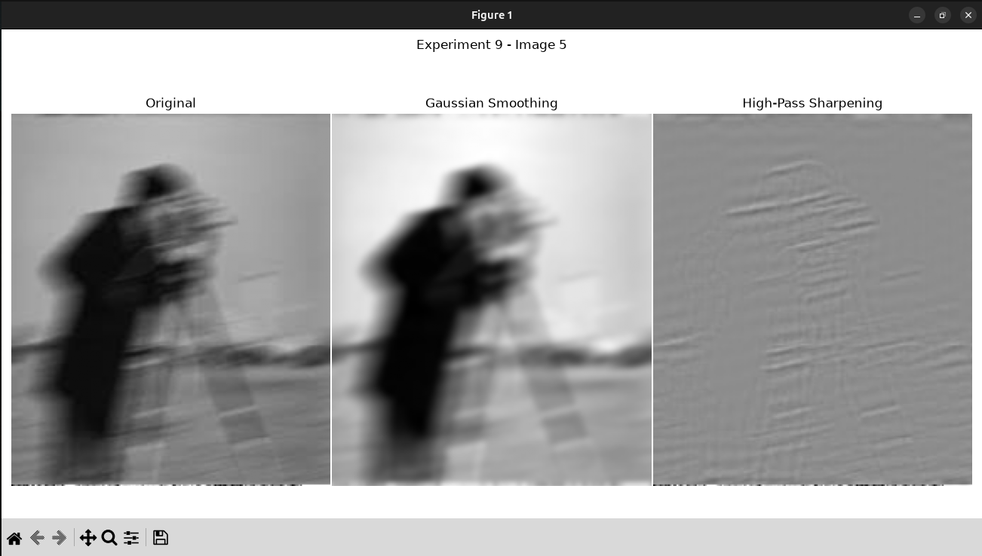
Observation :
- Gaussian smoothing (σ = 20) reduces high-frequency noise and smooths fine textures.
- Overall structure of images is preserved, but thin lines and small details are slightly blurred.
- Sharpening (strength = 20) enhances edges, boundaries, and prominent features.
- Noise in flat regions may be amplified and slight halos appear around strong edges.
- Across all four images, smoothing consistently cleans noisy areas.
- Sharpening consistently improves edge clarity and detail.
- The experiment highlights the trade-off between noise reduction and detail enhancement using frequency-
- domain filters.

1. Original Images
The original images contain their natural edges, textures, intensity variations, and fine details. These images are used as the reference for comparing the effects of the two filters.

2. Gaussian Smoothing
After applying the Gaussian low-pass filter, the images became smoother and softer. Fine details and rapid intensity variations were reduced.
The Gaussian filter suppresses high-frequency components, which are often associated with noise and fine image details.
The major observations were:
- Noise and small variations were reduced.
- The images appeared smoother.
- Fine textures became less prominent.
- Sharp edges became slightly blurred.
- Very small details were removed.
- Increasing smoothing strength would produce greater blurring.
Therefore, Gaussian smoothing is useful when the objective is to reduce noise or prepare an image for further processing.

3. High-Pass Sharpening
After applying the high-pass filter, edges and fine details became more prominent.
The high-pass filter removes the central low-frequency components and retains high-frequency components.
The major observations were:
- Edges became more visible.
- Boundaries appeared sharper.
- Fine details were emphasized.
- Texture information became more prominent.
- Noise could also become more visible.
- Excessive high-pass filtering can produce an unnatural appearance.

Conclusion :
From this experiment, we learn that smoothing effectively reduces noise and unwanted high-frequency components while slightly blurring edges and fine details. Gaussian smoothing produces a cleaner and more uniform appearance, making it useful for removing noise and small variations in an image. On the other hand, sharpening enhances edges, boundaries, textures, and other prominent features, making the image appear more defined and detailed. However, excessive sharpening can also amplify noise and introduce minor halos around strong edges.
The experiment demonstrates that frequency-domain filters provide an effective way to control the visual characteristics of an image. The results also show that the choice of filter parameters has a significant effect on the final image quality. A higher degree of smoothing may remove important details, while excessive sharpening may produce unnatural results. Therefore, achieving optimal image quality requires carefully balancing smoothing and sharpening parameters according to the characteristics and requirements of each image. Overall, frequency-domain filtering is a useful technique in image processing for noise reduction, enhancement, and improving the visual quality of images.

